AI-Powered Supply Chain Optimization Architecture Document
Table of Contents
1. Introduction & Business Context 2
Business Challenge 2
Strategic Goal 2
2. Requirements 2
2.1 Functional Requirements 2
2.2 Non-Functional Requirements (NFRs) 2
2.3 Metrics & KPIs 2
3. Architecture Overview 3
3.1 Building Blocks 3
4. AI & Automation Augmentation 5
5. Risks, Compliance & Trade-offs 5
Risks 5
Compliance 5
Trade-offs 5
6. Architecture Decision Records (ADRs) 5

1. Introduction & Business Context
During Black Friday, the company faces 15x normal demand variability, creating massive stress on inventory tracking, order fulfillment, and last-mile delivery. Manual decision-making is insufficient, leading to 15-20% order fulfillment errors and increased return rates.

Business Challenge
- Lack of real-time visibility into 200,000+ SKUs across warehouses and hubs.
- Inability to predict demand spikes accurately.
- Manual replenishment delays cause stockouts and overstocking.
- Inefficient routing leads to delayed deliveries.

Strategic Goal
Leverage AI-powered predictive demand modeling and workflow automation to enable:
- Seamless inventory optimization.
- Reduction in stockouts and returns.
- Proactive rerouting under volatile demand.

2. Requirements

2.1 Functional Requirements
- FR1: Real-time SKU tracking across all warehouses and last-mile hubs.
- FR2: AI-powered predictive demand forecasting (daily, hourly granularity).
- FR3: Automated replenishment triggers to suppliers and warehouses.
- FR4: Proactive rerouting of shipments based on demand and traffic signals.
- FR5: Integration with ERP, WMS, and logistics partners.
- FR6: Exception management dashboard with alerts for anomalies.

2.2 Non-Functional Requirements (NFRs)
- Scalability: Handle 15x traffic surge without downtime.
- Latency: < 2 seconds response time for SKU availability queries.
- Reliability: 99.99% uptime for order and inventory services.
- Data Freshness: Real-time updates (lag < 1 min).
- Security & Compliance: GDPR, CCPA, SOC 2 compliance.
- Explainability: AI models must provide interpretable forecasts for audits.

2.3 Metrics & KPIs
- Forecast Accuracy: ≥ 90%.
- Order Fulfillment Accuracy: ≥ 98%.
- Stockout Rate: ≤ 2%.
- Return Reduction: ≥ 15%.
- SLA Compliance for Delivery: ≥ 99%.

3. Architecture Overview

3.1 Building Blocks
Data Sources:
- POS data, ERP/WMS data, last-mile partner feeds, IoT sensors in warehouses.
Ingestion & Processing:
- Kafka-based event streaming for real-time SKU movements.
- Data Lakehouse (Delta Lake/Snowflake) for historical + real-time analytics.
AI/ML Layer:
- Predictive demand forecasting (time-series ML models, transformers).
- Anomaly detection for sudden demand shifts.
- Reinforcement learning for dynamic rerouting.
Automation Layer:
- Workflow orchestration (Airflow/Kubeflow).
- RPA bots for supplier order execution.
- API integration with ERP and 3PL logistics.
User Interfaces:
- Real-time dashboard for supply chain managers.
- Exception alerts via Slack/Email.
Infrastructure:
- Cloud-native microservices on Kubernetes.
- Auto-scaling, load balancing, and multi-region failover.
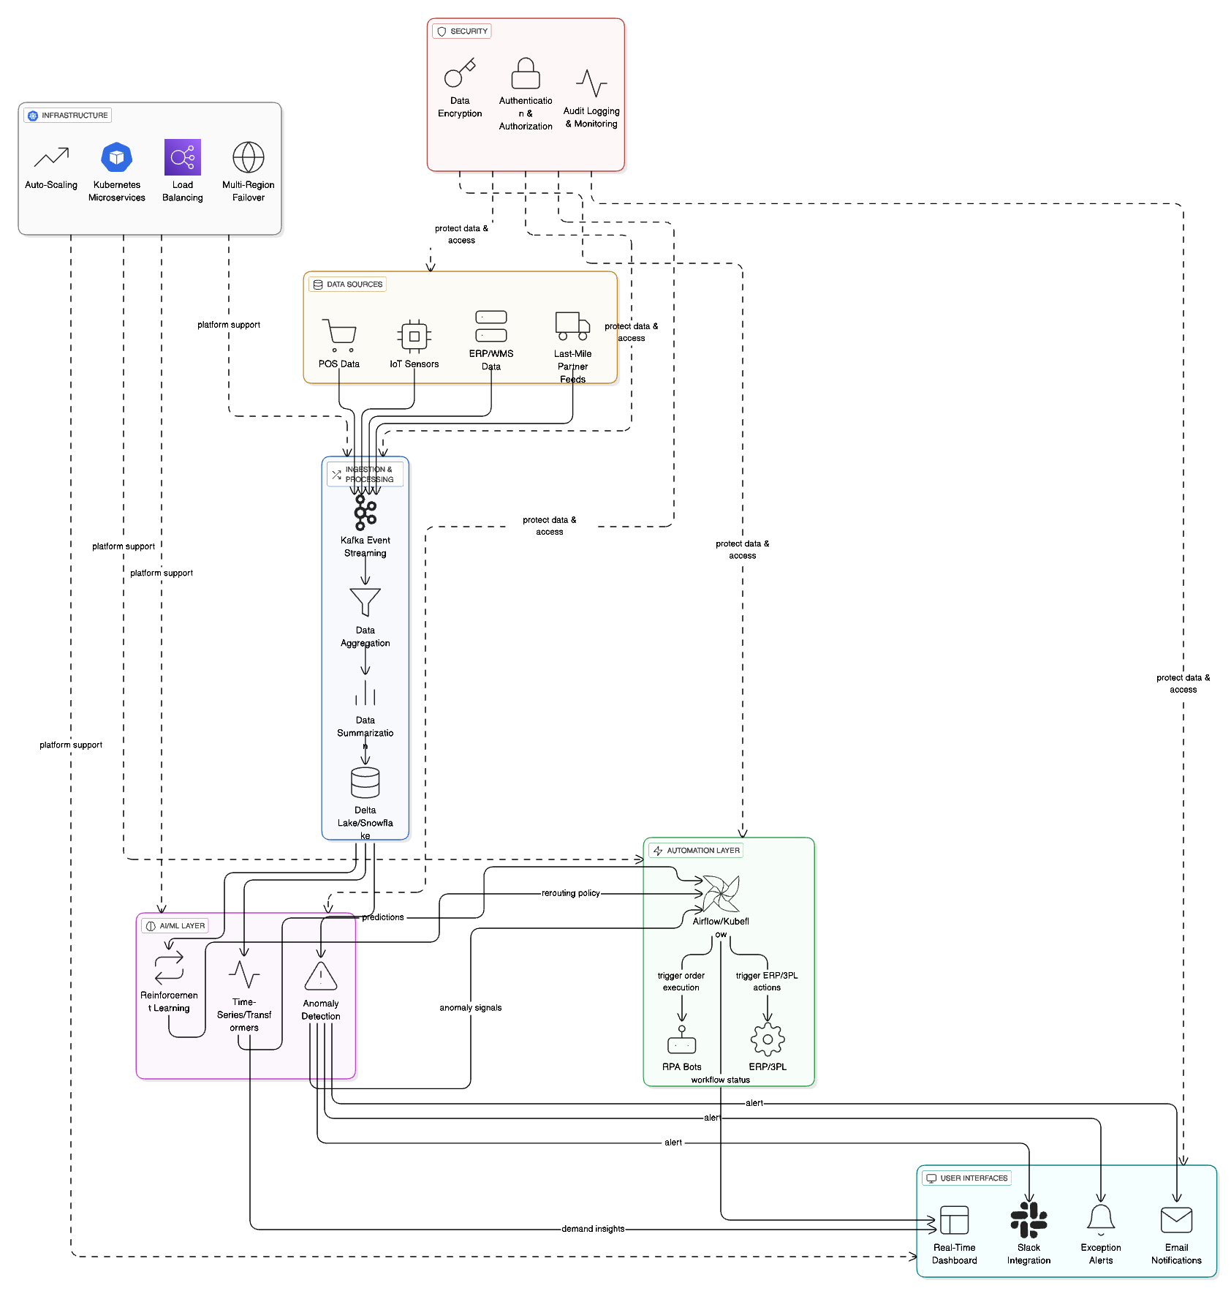

4. AI & Automation Augmentation
Predictive Analytics: AI models forecast SKU demand by region, time, and channel.
Fraud/Anomaly Detection: Detects abnormal order spikes.
Automation: Auto-replenishment orders raised via API; Dynamic shipment rerouting based on ML predictions + real-time traffic; Infrastructure orchestration (auto-scale clusters during peak demand).

5. Risks, Compliance & Trade-offs

Risks
- Model Drift: Demand prediction accuracy may degrade if consumer behavior shifts.
- Data Latency: Delays in partner feeds can reduce forecast reliability.
- Over-automation: Excessive automation may reduce human oversight.

Compliance
- Personal data in orders must adhere to GDPR/CCPA.
- Vendor integration must align with SOC 2 and ISO 27001.

Trade-offs
- Accuracy vs Speed: Higher accuracy ML models may have longer compute times.
- Cloud Costs vs Resilience: Multi-region failover ensures resilience but increases costs.
- Automation vs Control: Full automation improves speed but may reduce manual override flexibility.

6. Architecture Decision Records (ADRs)
ADR | Decision | Rationale | Alternatives | Status
01 | Use Kafka for event streaming | Scalable, low-latency SKU updates | RabbitMQ, Kinesis | Accepted
02 | Use ML models (Prophet + Transformers) | Handles time-series + sudden spikes | ARIMA, LSTM | Accepted
03 | Deploy on Kubernetes multi-region cluster | Scalability + resilience | Monolithic cloud setup | Accepted
04 | Integrate with ERP via APIs | Seamless automation of replenishment | Manual/batch integration | Accepted
05 | Human-in-loop override for automation | Balances risk & control | Fully automated | Accepted

